
SKILLLOOP: A RECIPROCAL SKILL-EXCHANGE PLATFORM FOR PEER LEARNING
VEERAJEBIKA.R – 24623132
POOJA.S – 24623144
GRACY ROSE.A – 24623110
BATCH NO. 05
MINI PROJECT REPORT
Submitted to the
SCHOOL OF ENGINEERING
DEPARTMENT OF COMPUTER SCIENCE AND ENGINEERING (ARTIFICIAL INTELLIGENCE)
in partial fulfillment of the requirements for the award of the degree of
BACHELOR OF TECHNOLOGY
IN
COMPUTER SCIENCE AND ENGINEERING (ARTIFICIAL INTELLIGENCE)
VELS INSTITUTE OF SCIENCE, TECHNOLOGY AND ADVANCED STUDIES (VISTAS)
CHENNAI – 600 117
OCTOBER 2026

BONAFIDE CERTIFICATE
Certified that this project report "SKILLLOOP: A RECIPROCAL SKILL-EXCHANGE PLATFORM FOR PEER LEARNING" is the bonafide work of VEERAJEBIKA.R – 24623132, POOJA.S – 24623144 and GRACY ROSE.A – 24623110, who carried out the project under my supervision. Certified further that, to the best of my knowledge, the work reported here does not form part of any other project report or dissertation on the basis of which a degree or award was conferred on an earlier occasion on this or any other candidate.

SIGNATURE OF THE HOD  Head of the Department  Assistant Professor, Department of Computer Science and Engineering  School of Engineering  VISTAS, Chennai | SIGNATURE OF THE SUPERVISOR  Dr. G. REVATHY  Assistant Professor, Department of Computer Science and Engineering  School of Engineering  VISTAS, Chennai

Submitted for the Project Work and Viva-Voce examination held on 30 October 2026 at Vels Institute of Science, Technology and Advanced Studies (VISTAS), Chennai – 600 117.

INTERNAL EXAMINER | EXTERNAL EXAMINER

DECLARATION
We, Veerajebika.R, Pooja.S and Gracy Rose.A, students of Bachelor of Technology in Computer Science and Engineering (Artificial Intelligence), Department of Computer Science and Engineering (Artificial Intelligence), Vels Institute of Science, Technology and Advanced Studies (VISTAS), Chennai, hereby declare that the mini project report entitled "SkillLoop: A Reciprocal Skill-Exchange Platform for Peer Learning" is an original work carried out by us under the guidance of Dr. G. Revathy. This work has not been submitted, in part or in full, to any other university or institution for the award of any degree or diploma.

Place: Chennai
Date: 30 October 2026

VEERAJEBIKA.R – 24623132
POOJA.S – 24623144
GRACY ROSE.A – 24623110

ACKNOWLEDGEMENT
It is a great delight and a proud privilege to acknowledge the help and support we received from the many people who made this project possible. We thank the FOUNDER & CHAIRMAN, Shri. Dr. ISHARI K. GANESH, for the infrastructure and laboratory facilities that motivated the completion of this work. We are grateful to our HEAD OF THE DEPARTMENT, Head of the Department, for continuous support and encouragement. We express our sincere thanks to our PROJECT GUIDE, Dr. G. REVATHY, for patient guidance and valuable advice throughout the project. We also thank the staff members, the librarian and the non-teaching staff of the Computer Centre for their help. Last but not least, we thank our parents and friends for their support and encouragement.

VEERAJEBIKA.R – 24623132
POOJA.S – 24623144
GRACY ROSE.A – 24623110
ABSTRACT
SkillLoop is a web-based peer-to-peer skill-exchange platform designed to connect individuals who wish to share their existing skills and acquire new ones through collaborative learning. The system enables users to create profiles, maintain lists of skills they can teach and skills they want to learn, search for suitable partners, and discover reciprocal learning opportunities. It implements a rule-based matching algorithm that compares users’ skill lists in both directions and calculates an interpretable match score. A recommendation module further ranks potential partners and provides textual explanations for the suggestions.
The application is developed using Python and Django, with SQLite serving as the database through the Django Object-Relational Mapping (ORM). Its additional features include skill-exchange requests, collaborative rooms, text chat, browser-based video communication using WebRTC, mentor booking, and a token-based incentive mechanism. Security measures include user authentication, CAPTCHA verification, a honeypot field, and login throttling. A rule-based assistant responds to user queries, with optional integration of an external language model when configured.
The platform brings partner discovery, communication, mentoring, and learning incentives together within a single web application. However, the current matching mechanism relies on exact skill-name comparisons, and the recommendation scores are rule-based rather than trained or calibrated using user data. Advanced machine-learning recommendations, semantic skill matching, and project recommendations represent potential areas for future development.
SkillLoop demonstrates the implementation of a modular web-based platform that facilitates reciprocal skill exchange and collaborative learning. By enabling users to teach skills they already possess while learning skills they wish to acquire, the system aims to encourage peer-to-peer knowledge sharing and provide an integrated environment for skill development.
Keywords: Skill Exchange, Peer Learning, Reciprocal Matching, Recommender System, Learning by Teaching, Django, WebRTC.
TABLE OF CONTENTS
CHAPTER NO. | TITLE | PAGE NO.
 | ABSTRACT | i
 | LIST OF FIGURES AND TABLES | iii
 | LIST OF ABBREVIATIONS | iv
1 | CHAPTER 1 – INTRODUCTION | 1
 | 1.1 Overview of the project | 1
 | 1.2 Scope and objective | 2
2 | CHAPTER 2 – REVIEW OF THE LITERATURE | 4
 | 2.1 Literature overview | 4
 | 2.2 Research summary | 4
3 | CHAPTER 3 – SYSTEM DESIGN | 7
 | 3.1 Existing system | 7
 | 3.2 Proposed system | 7
 | 3.3 System architecture | 9
 | 3.4 Data flow / workflow | 10
 | 3.5 Hardware requirements | 13
 | 3.6 Software requirements | 14
4 | CHAPTER 4 – IMPLEMENTATION | 15
 | 4.1 Methodology | 15
 | 4.2 Implementation | 16
 | 4.2.1 User Registration and Authentication | 16
 | 4.2.2 Profile, Skill Management and Search | 16
 | 4.2.3 Reciprocal Skill-Matching Algorithm | 16
 | 4.2.4 Rule-Based Recommendation Scoring | 17
 | 4.2.5 Skill-Exchange Requests | 17
 | 4.2.6 Collaborative Rooms, Chat and WebRTC Video | 18
 | 4.2.7 Mentor Discovery and Booking | 18
 | 4.2.8 Token Wallet and Teaching Rewards | 18
 | 4.2.9 Captcha, Honeypot and Login Throttling | 19
 | 4.2.10 Chatbot Assistant | 19
 | 4.3 Module integration | 19
5 | CHAPTER 5 – RESULTS, CONCLUSION AND FUTURE WORK | 20
 | 5.1 Results and evaluation | 20
 | 5.2 Discussion | 24
 | 5.3 Challenges and limitations | 25
 | 5.4 Conclusion | 25
 | 5.5 Future work | 25
 | REFERENCES | 27
LIST OF FIGURES
FIGURE NO. | TITLE | PAGE NO.
3.1 | Use-case diagram of SkillLoop | 8
3.2 | System architecture of SkillLoop | 9
3.3 | Flow of a user through SkillLoop | 10
3.4 | Level 0 data-flow diagram (context diagram) | 11
3.5 | Level 1 data-flow diagram | 11
3.6 | Entity-relationship diagram of SkillLoop | 12
3.7 | Flowchart of the reciprocal matching procedure | 13
4.1 | Project timeline (Gantt chart from the project presentation) | 16
5.1 | Match and recommendation scores for the scenarios of Table 5.3 (calculated, not measured) | 22
5.2 | Login page with security code
5.3 | User profile with Can teach and Wants to learn skills
5.4 | Dashboard with token balance, reciprocal matches, recommendations and incoming requests | 23
5.5 | Live class with WebRTC video call and typed class chat
5.6 | Mentors page – become a mentor or find one
5.7 | Booking a mentor session (2-token fee)
5.8 | My Bookings – mentor requests and booked sessions
5.9 | Matches page | 24
5.10 | Tokens page with ledger | 24
LIST OF TABLES
TABLE NO. | TITLE | PAGE NO.
2.1 | Comparison with existing work | 5
2.2 | Base-paper proposals versus the SkillLoop implementation | 5
3.1 | Functional requirements | 7
3.2 | Modules and their principal components | 9
3.3 | Core database entities | 12
3.4 | Indicative hardware requirements | 13
3.5 | Software requirements | 14
4.1 | Default token rules (settings file) | 18
4.2 | Security parameters | 19
5.1 | Coverage of the automated test suite (as reported in the conference paper) | 20
5.2 | Representative test cases | 20
5.3 | Worked scoring examples from Eqs. 4.2 and 4.3 | 21
LIST OF ABBREVIATIONS
ABBREVIATION | FULL FORM
AI | Artificial Intelligence
API | Application Programming Interface
CAPTCHA | Completely Automated Public Turing test to tell Computers and Humans Apart
CSRF | Cross-Site Request Forgery
CSS | Cascading Style Sheets
DFD | Data-Flow Diagram
ER | Entity-Relationship
HMAC | Hash-based Message Authentication Code
HTML | HyperText Markup Language
HTTP | Hypertext Transfer Protocol
LLM | Large Language Model
ORM | Object-Relational Mapping
SQL | Structured Query Language
STUN | Session Traversal Utilities for NAT
TURN | Traversal Using Relays around NAT
UI | User Interface
URL | Uniform Resource Locator
UUID | Universally Unique Identifier
WebRTC | Web Real-Time Communication

CHAPTER 1 – INTRODUCTION

1.1 OVERVIEW OF THE PROJECT
Introduction
Technical skills such as programming, data analysis and design are often learned through practice and interaction with other learners. A 2025 systematic review examines how artificial intelligence can support peer-learning processes, including personalized support and feedback [1]. Recent work on dynamic peer-learning recommendations also explores how learner interactions and changing needs can be used to recommend peers and learning materials [2]. These studies provide context for a platform in which each member can be both teacher and learner; they do not establish that SkillLoop itself improves learning outcomes, and this report makes no such claim.
A skill-exchange platform applies this idea at the level of a community. Each member declares the skills he or she can teach and wants to learn, and the platform helps members find one another. A 2026 skill-exchange paper proposes intelligent skill matching and project recommendations as a conceptual design [5]. SkillLoop develops a working student prototype focused on reciprocal matching, communication between matched users, mentoring and a token-based incentive for teaching.
Problem Statement
Learners who wish to exchange skills with peers face four practical difficulties:
- Discovery: there is no simple way to find a person whose teaching skills match one's learning needs and whose learning interests match one's own teaching skills.
- Reciprocity: one-directional help is hard to sustain, because the helper receives nothing in return.
- Meeting: even after a suitable partner is found, a separate tool is needed for conversation, video calls and scheduling.
- Motivation and abuse: without an incentive for teaching, members may only consume help, while open registration invites automated sign-ups and misuse.
The problem addressed by this project is to design and implement a single web application that identifies reciprocal skill partners, explains the suggestion, and gives matched users the means to start learning together.
System Overview
SkillLoop is a Django web application backed by SQLite. A member records skills in two lists, "Can teach" and "Wants to learn". For every other active member the system intersects the two lists in both directions; members for whom both intersections are non-empty are reciprocal matches and always rank above members who can help in one direction only. A recommendation step adds an activity term and generates a reason for each suggestion. From a match or a search result a member can send an exchange request, meet in a live room with text chat and a browser-based video call, or book a member who has chosen to be listed as a mentor. Joining a room and requesting a mentor session cost tokens, and tokens are earned when a learner confirms that a lesson was taught. A self-hosted captcha, a honeypot field and login throttling protect the forms, and a rule-based assistant answers common questions.
Advantages of the System
- Transparent matching: any score can be reproduced by hand from two skill lists and two profiles.
- Reciprocity by construction: every reciprocal match outranks every one-way match.
- End-to-end flow: a suggestion can become a conversation, a video session or a mentor booking without leaving the application.
- Teaching incentive: tokens link access to sessions with teaching, and anti-abuse limits restrict token farming.
- No special infrastructure: the core features run on Python, Django and SQLite with no machine-learning service or paid external API.
- Entry-point protection: the captcha, honeypot and throttling reduce automated misuse of the forms.
These advantages are design properties of the implementation; the report does not claim improved academic performance or any other measured learning outcome.

1.2 SCOPE AND OBJECTIVE
Objectives
- To provide user registration, authentication and profile management, with separate lists of skills a user can teach and wants to learn.
- To implement a reciprocal skill-matching procedure that produces an interpretable score for each candidate partner.
- To rank partners with a rule-based recommendation score and generate a short textual reason for every suggestion.
- To support skill-exchange requests, collaborative rooms with text chat, browser-based voice and video communication, and mentor booking.
- To introduce a token wallet and ledger that links access to rooms and mentor sessions to teaching, within anti-abuse limits.
- To protect the application with a captcha, a honeypot field and login throttling, and to offer a rule-based assistant for user queries.
Scope of the Project
SkillLoop is a prototype web application for students and self-learners who want to exchange skills with peers. The scope covers the modules listed above as they exist in the Django implementation. Semantic or embedding-based skill matching, trained machine-learning recommendation, the project-recommendation section proposed in [5], reputation-based ranking, match notifications and mobile applications are outside the scope and are treated as future work. No user study, load test or production deployment has been carried out, so the report makes no claim about learning outcomes, accuracy or scalability.

CHAPTER 2 – REVIEW OF THE LITERATURE

2.1 LITERATURE OVERVIEW
Recent research relevant to SkillLoop covers AI-supported peer learning, dynamic peer-learning recommendations, general recommender-system methods, people-to-people recommendation and skill-exchange platforms. This literature survey summarizes only the 2025–2026 papers listed in the References section and identifies the gap addressed by the project.

2.2 RESEARCH SUMMARY
Peer, Collaborative and Teaching-Based Learning
A 2025 systematic literature review examines how artificial intelligence supports peer learning through personalized feedback, support and learning activities, while noting that the effects depend on the learning context and design [1]. A 2026 study proposes dynamic peer-learning recommendations that combine collaborative filtering, content-based methods and interaction-based clustering to recommend peers and study materials [2]. These works motivate a platform in which members can learn from one another; they do not establish that SkillLoop itself improves learning outcomes, and this report makes no such claim.
Recommender Systems and Reciprocal Recommendation
A 2025 survey reviews recommender-system approaches, including collaborative filtering, content-based methods and hybrid approaches, and discusses challenges such as cold-start problems and personalization [3]. For people-to-people recommendation, a 2026 study introduces a preference-driven matching framework intended to help users express preferences and refine matches [4]. These approaches show the relevance of recommending suitable learning partners rather than only recommending courses or resources. SkillLoop applies the same broad goal through transparent, rule-based comparisons of the skills each member can teach and wants to learn; it does not use a trained recommendation model.
Enabling Technology and Project-Based Learning
Recent peer-learning recommendation research explores how learner interactions and changing needs can guide recommendations of peers and study materials [2]. The 2026 skill-exchange paper proposes a platform that matches people based on skills they possess and skills they want to learn, with additional project recommendations [5]. SkillLoop follows the skill-exchange direction but implements an inspectable reciprocal score, live rooms and mentor booking; it does not implement the base paper’s proposed project-recommendation module. Table 2.1 positions SkillLoop against these recent works.
Table 2.1: Comparison with existing work
Ref. | Approach | Position of SkillLoop
[5] | 2026 skill-exchange platform with intelligent matching | Working reciprocal score; project recommendations not implemented
[1] | 2025 review of AI-supported peer learning | Supports the motivation for peer learning; SkillLoop outcomes not measured
[3] | 2025 survey of recommender-system methods | Recommends people based on skills in both directions
[4] | 2026 people-to-people recommendation framework | Uses transparent reciprocal skill overlap rather than preference-driven visualization
[2] | 2026 dynamic peer-learning recommendations | Peer recommendation is relevant; SkillLoop uses a simpler rule-based method

Base Work and Research Gap
The base work proposes a skill-exchange workflow involving registration, skill input, profile storage, skill comparison, match identification, project recommendation and collaboration, and suggests additional features such as vector embeddings, trade cycles, reputation, notifications, gamification and asynchronous processing [5]. SkillLoop addresses the prototype requirements by specifying an inspectable scoring rule, providing live rooms and mentor booking, and adding a token mechanism, captcha, honeypot and login throttling. Table 2.2 maps the base paper’s proposals to their status in SkillLoop.
Table 2.2: Base-paper proposals versus the SkillLoop implementation
Proposal in base work | Status in SkillLoop
Profiles with skills held and wanted | Implemented (UserProfile and Skill models)
Complementary skill matching | Implemented: set intersection in both directions, score 1–100
Vector-embedding proximity | Not implemented; names compared as lower-cased strings
Bidirectional "trade cycles" | Pairwise reciprocity only; no cycles of three or more
Reputation / verification ranking | Not used for ranking; learner confirmation gates token rewards
Project recommendation section | Not implemented; no model, view or template exists
Collaboration between matched users | Implemented: requests, live rooms, mentor booking
Match notifications | Not implemented; pending requests shown on dashboard
Gamification | Partial: token wallet and ledger; no badges or leaderboards
Secure coordination | Partial: login, CSRF, captcha; no private messaging
Asynchronous matching for scale | Not implemented; matching runs per page request

CHAPTER 3 – SYSTEM DESIGN

3.1 EXISTING SYSTEM
Skill sharing among students often takes place through informal or general-purpose methods: friends help one another through chat groups or in person; course platforms supply learning content; and discussion forums allow public questions without necessarily matching users by skills. Recent surveys discuss recommender systems for personalized suggestions [3], while newer peer-learning and people-to-people recommendation studies focus on recommending suitable peers and matching users according to their needs and preferences [2], [4]. SkillLoop differs by focusing on reciprocal skill exchange: each suggested partner should be able to teach something the other wants to learn.
Limitations of the Existing System
- Partner discovery is manual and depends on chance.
- Two-sided (reciprocal) compatibility is not modeled, so offers of help are often one-directional.
- Communication, scheduling and mentoring are scattered across separate tools.
- There is no incentive that rewards members for teaching.
- Open platforms are exposed to bot registrations and repeated login attempts unless explicit safeguards are provided.

3.2 PROPOSED SYSTEM
SkillLoop brings reciprocal partner discovery, communication, mentoring and learning incentives together in one browser-based application. Table 3.1 lists its functional requirements with their status, following the module inventory of the SkillLoop conference paper, which was prepared from the project source code.
Table 3.1: Functional requirements
ID | Requirement | Status
FR1 | Register with username, e-mail, full name and password; reject duplicates (case-insensitive) and passwords under six characters | Implemented
FR2 | Log in with username or e-mail after passing the security code | Implemented
FR3 | Maintain a profile (biography, location, interests, experience level, picture) and opt in as a mentor | Implemented
FR4 | Add, edit and delete "Can teach" / "Wants to learn" skills with category and level; owner-only changes | Implemented
FR5 | Search other members' teach skills by keyword, category and level | Implemented
FR6 | Compute reciprocal matches with a score from 1 to 100 | Implemented
FR7 | Rank partners with a recommendation score and a textual reason | Implemented
FR8 | Send, accept, reject and cancel exchange requests | Implemented
FR9 | Create and join rooms with a code and capacity; exchange typed text messages | Implemented
FR10 | Browser-based voice/video call for up to six participants | Implemented
FR11 | Book a mentor for a date, time and duration; mentor confirms or declines | Implemented
FR12 | Token wallet with append-only ledger; reward teaching after learner confirmation | Implemented
FR13 | Captcha at login and room join, honeypot, throttling of failed logins | Implemented
FR14 | Submit feedback; administrators respond | Implemented
FR15 | Rule-based assistant; optional external language model if configured | Implemented (LLM path optional)
FR16 | Recommend projects to matched users | Proposed
FR17 | Semantic (embedding) skill matching and match notifications | Proposed

The main non-functional properties are security (hashed passwords, CSRF protection, HttpOnly session cookie with SameSite=Lax, per-owner access checks, captcha, honeypot and lockout), usability (server-rendered pages, JavaScript only for live updates), interpretability (scores reproducible by hand), portability and maintainability. Performance has not been measured, and scalability beyond a single development process is proposed future work. Figure 3.1 shows the actors and use cases: the member (learner and teacher), the mentor (a member who has opted in) and the administrator, who acts through the Django admin site.
Figure 3.1: Use-case diagram of SkillLoop

3.3 SYSTEM ARCHITECTURE
SkillLoop follows the three-layer structure of a Django application (Figure 3.2). The presentation layer consists of 26 Django templates with one shared stylesheet; JavaScript appears only where a page must update without reloading (room chat polling, video-call signaling, the assistant widget and captcha refresh). The application layer is a single Django app named swap, in which 42 URL routes map to view functions that hand validation to forms, scoring to a matching module, wallet rules to a token module, the captcha and throttling to security modules, and chatbot replies to an assistant module. The data layer uses the Django ORM on an SQLite file. Browsers contact public STUN servers (and optionally a TURN relay) for peer-to-peer media, and the assistant can call an external language-model API if a key is present. The counts of 26 templates and 42 routes are taken from the conference paper as described in the project documentation.
Figure 3.2: System architecture of SkillLoop
Table 3.2: Modules and their principal components
Module | Principal components | Interacts with
Authentication and profile | RegisterForm, LoginForm, auth views; User, UserProfile | Security, skills
Skills and search | Skill model; skill views; search view (first 50 results) | Matching, requests
Matching and recommendation | matching.py: find_matches_for_user, get_recommendations_for_user | Skills, profile, dashboard
Exchange requests | SkillRequest model; four request views | Matching, search
Rooms, chat and video | SkillRoom, RoomMessage, CallPresence, CallSignal; polling API; WebRTC script | Tokens, security
Mentor booking | MentorBooking model and views | Profile, tokens
Token economy | tokens.py; TokenWallet, TokenTransaction, TeachSession | Rooms, mentors
Security | captcha.py, security.py, middleware.py | Login, registration, rooms
Assistant and feedback | ai.py; ChatMessage, Feedback | Admin site

3.4 DATA FLOW / WORKFLOW
Figure 3.3 shows the path of a user through the system, from registration and login with the security code to skill entry, reciprocal matching, ranked recommendations, an exchange request and collaboration through rooms, mentors and tokens.
Figure 3.3: Flow of a user through SkillLoop
The context diagram (Figure 3.4) treats SkillLoop as one process exchanging data with the member, the mentor, the administrator and the optional external language-model service. The level-1 diagram (Figure 3.5) decomposes it into eight processes and seven groups of data stores; the matching process (3.0) reads the profile and skill stores but writes nothing, and the token process (7.0) is also called by the room and mentor processes, which charge or refund tokens through the same ledger.
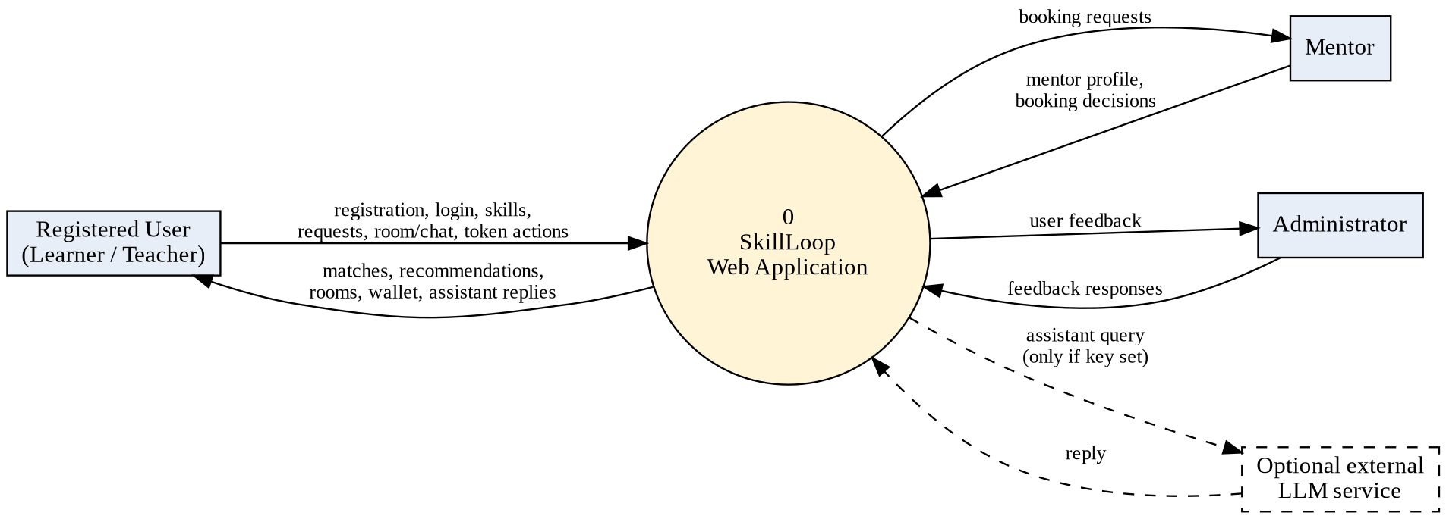
Figure 3.4: Level 0 data-flow diagram (context diagram)
Figure 3.5: Level 1 data-flow diagram
Figure 3.6 shows the 13 application models and their relationships to Django's built-in User model. Skills are kept in a single table with a type field, so the same search and matching code can treat "teach" and "learn" entries symmetrically. The token ledger is append-only, and each entry stores the resulting balance, which makes every balance change auditable. Field-level definitions should be confirmed against models.py.
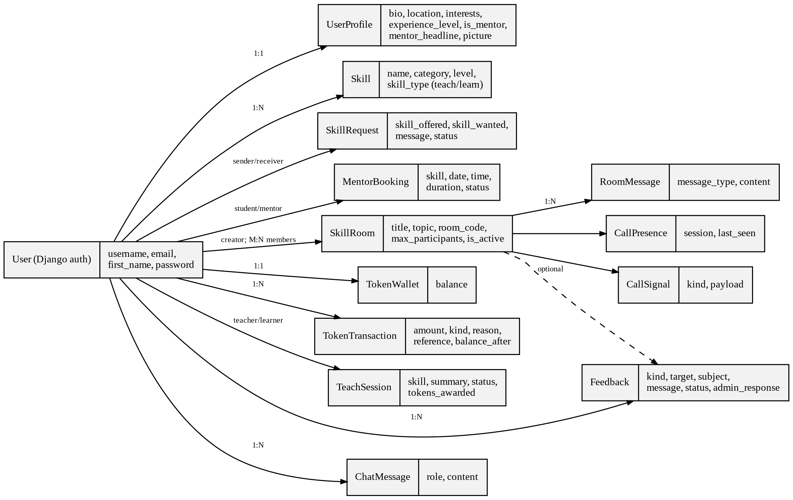
Figure 3.6: Entity-relationship diagram of SkillLoop
Table 3.3: Core database entities
Entity | Purpose
User, UserProfile | Account; biography, location, interests, experience level, mentor flag and headline, picture
Skill | Name, category, level and type (teach / learn) per user
SkillRequest, MentorBooking | Sender, receiver, skills, message and status; student, mentor, skill, date, time, duration, status
SkillRoom, RoomMessage | Title, topic, room code, capacity, active flag, members; typed chat messages
CallPresence, CallSignal | Who is in a call; offer, answer and candidate messages
TokenWallet, TokenTransaction, TeachSession | Balance; append-only ledger with balance after each entry; teacher, learner, skill, summary, status, tokens awarded
Feedback, ChatMessage | Reports with target, subject, message, status and admin response; assistant history

Figure 3.7 gives the flowchart of the reciprocal matching procedure, which is specified mathematically in Section 4.2.3.
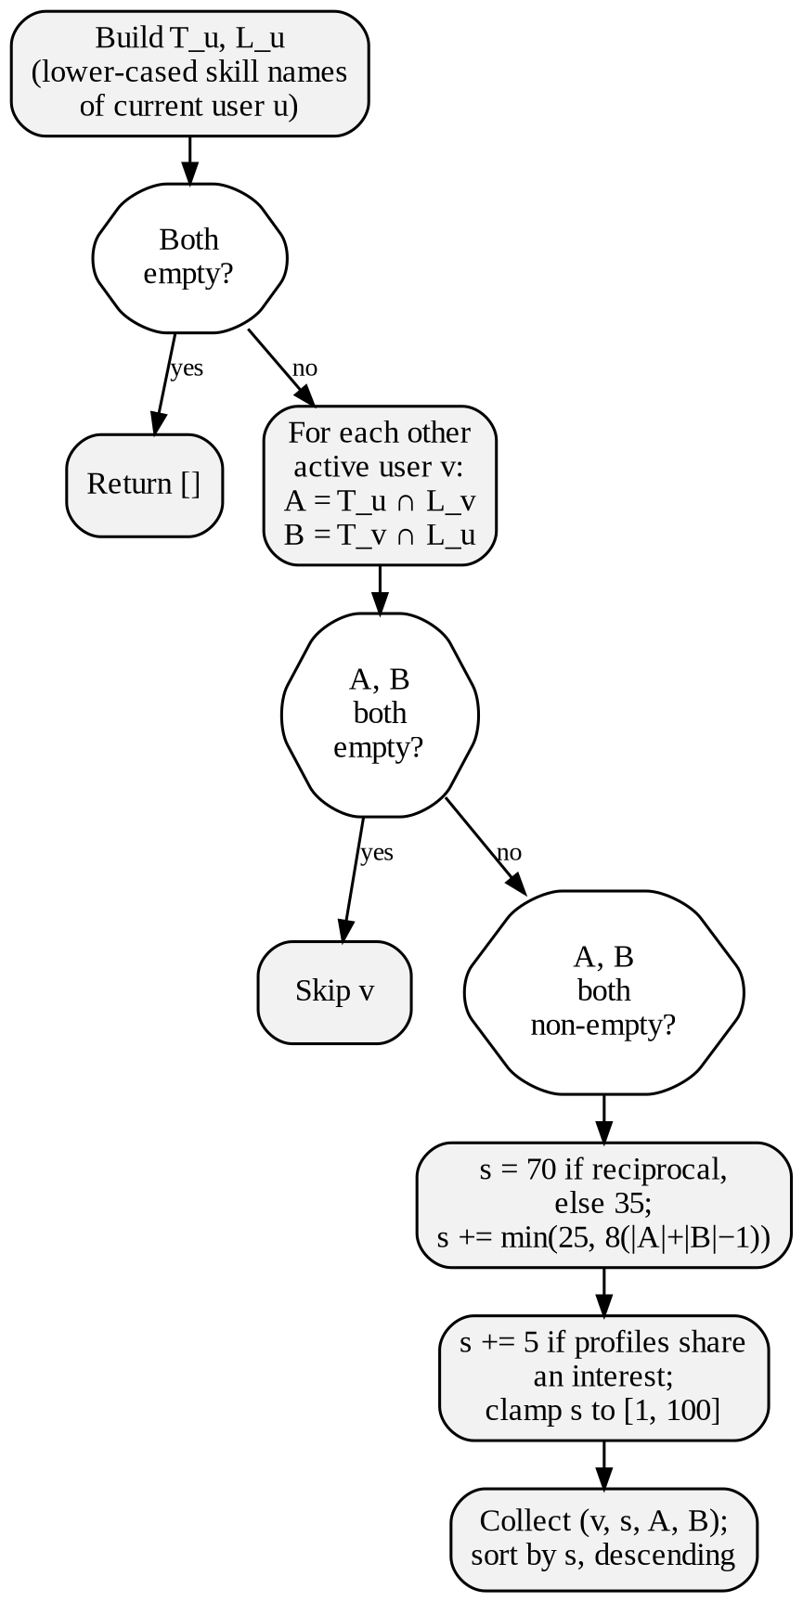
Figure 3.7: Flowchart of the reciprocal matching procedure

3.5 HARDWARE REQUIREMENTS
Table 3.4: Indicative hardware requirements
Component | Requirement
Server / development machine | Any modern computer able to run Python and Django (for example, a dual-core processor and 4 GB RAM)
Storage | Sufficient for the project files, the SQLite database file and uploaded profile pictures
Client device | Computer or laptop with a modern browser
Camera and microphone | Required on the client only for video or voice calls
Network | Internet access for STUN servers used by WebRTC; optional TURN relay where direct connections fail

The conference paper does not specify hardware; these are indicative figures that have not been benchmarked.

3.6 SOFTWARE REQUIREMENTS
Table 3.5: Software requirements
Layer | Technology
Language / framework | Python; Django (requirements.txt: 5.0 or later and below 5.3)
Database | SQLite through the Django ORM
Imaging library | Pillow (captcha image and profile pictures)
Front end | Django templates, HTML, one CSS file, JavaScript (fetch, WebRTC)
Live updates | HTTP polling for chat and call signaling; no WebSockets
Voice / video | Browser WebRTC, peer-to-peer mesh, STUN, optional TURN
Assistant | Keyword rule base; optional external language-model call if a key is set
Cache | Django local-memory cache (captcha records and lockouts)

CHAPTER 4 – IMPLEMENTATION

4.1 METHODOLOGY
SkillLoop was built as a single Django app (swap) using a modular approach: each feature is a group of models, forms, views and templates, and cross-cutting rules (matching, tokens, security, assistant) are kept in separate Python modules. The descriptions in this chapter are based on the module inventory and technical description in the SkillLoop conference paper, which were prepared from the source code; file and function names are quoted as they appear in the paper as described in the project documentation. Core features need no machine-learning infrastructure or paid external service. The project followed six stages:
- Requirement analysis: identifying user needs, skill-sharing requirements, mentor booking and online communication features.
- System design: designing the architecture, database structure, user interface and module interactions.
- Module development: building authentication, profiles, skills, reciprocal matching, recommendations, mentor booking, tokens and feedback.
- Module integration: connecting the modules so users can discover learning partners and use all platform features.
- Testing and validation: testing individual modules and the complete workflow.
- Deployment and maintenance: preparing for deployment and improving the system using testing and user feedback.
Figure 4.1 shows the project timeline from July to October 2026, from project kick-off and literature survey through database design, skill management, reciprocal matching, skill requests, recommendation, testing, module integration, final testing, documentation and UI/UX improvements to project closure.
Figure 4.1: Project timeline (Gantt chart from the project presentation)

4.2 IMPLEMENTATION

4.2.1 User Registration and Authentication
Input: username, e-mail, full name, password and confirmation; at login, username or e-mail, password and the security code. Processing: the registration form requires at least six characters and rejects a password mismatch and any username or e-mail that already exists (case-insensitive). The password is stored with Django hashing, an empty profile and wallet are created and the user is logged in. At login the identifier may be a username or an e-mail address, and failed attempts are counted for throttling (Section 4.2.9). Output: a logged-in session or a validation error. Components: RegisterForm, LoginForm and the authentication views in swap/forms.py and swap/views.py.

4.2.2 Profile, Skill Management and Search
The profile stores a biography, location, comma-separated interests, experience level, optional picture (Pillow ImageField), a mentor checkbox and a short mentor headline; interests feed the match score and the mentor flag controls mentor discovery. Skills have a name, a category chosen from ten, a level chosen from four (Beginner to Expert) and a type, "Can teach" or "Wants to learn", kept in a single Skill table; only the owner may edit or delete an entry, and names are lower-cased and whitespace-trimmed for matching. The search view filters other members' "Can teach" skills by keyword, category and level and returns the first 50 results, from which an exchange request can be sent.

4.2.3 Reciprocal Skill-Matching Algorithm
The algorithm is implemented in find_matches_for_user. It uses exact-string comparison of skill names; it does not use embeddings, semantic similarity or a trained model. Let T(u) be the set of lower-cased, trimmed names of skills user u can teach and L(u) the set u wants to learn. For the current user u and each other active user v:
A = T(u) ∩ L(v), B = T(v) ∩ L(u), n = |A| + |B| (4.1)
A contains the skills u can teach v and B those v can teach u. If both are empty, v is skipped; the pair is reciprocal if both are non-empty. The match score is
s = clamp( b + min(25, 8(n − 1)) + δ, 1, 100 ) (4.2)
where b is 70 for a reciprocal pair and 35 otherwise, and δ is 5 if the profiles share at least one interest (case-insensitive) and 0 otherwise. The constants are fixed in the code and were not tuned on data. A one-way match can score at most 35 + 25 + 5 = 65, whereas a reciprocal match has n ≥ 2 and scores at least 70 + 8 = 78, so every reciprocal match outranks every one-way match by construction. Results are sorted by s in descending order.
Worked example. Student u can teach Python and wants to learn Artificial Intelligence; candidate v can teach Artificial Intelligence and wants to learn Python, has listed four skills and shares no interest with u. Then A = {python}, B = {artificial intelligence}, n = 2, and s = 70 + min(25, 8 × 1) + 0 = 78. With four listed skills the activity term (Eq. 4.3) is 2, so r = 80. With a shared interest, s = 83 and r = 85; a one-way candidate with one overlapping skill and three listed skills scores s = 35 and r = 36. These values are calculated from the equations, not measured from users.

4.2.4 Rule-Based Recommendation Scoring
get_recommendations_for_user reuses the match list. For a candidate v with |S(v)| skills of either type it computes
r = clamp( s + ⌊ min(10, |S(v)|) / 2 ⌋, 1, 100 ) (4.3)
and re-sorts the list by r. The activity term contributes 0 to 5 points and cannot reverse the ordering between reciprocal and one-way matches. For each candidate, up to two sentences naming at most two skills in each direction explain the suggestion. The recommendations page lists the top twelve suggestions and the dashboard shows the top three. The interface labels r an "AI Match Score", but it is a hand-written rule with no learned model; it has not been trained, calibrated or validated on user data.

4.2.5 Skill-Exchange Requests
A member names the receiver, the skill offered, the skill wanted and an optional message; a SkillRequest is created as pending. The receiver may accept or reject and the sender may cancel. Acceptance records agreement only; the pair then coordinates in a live room or through a mentor booking. The status "Completed" is defined but no view sets it.

4.2.6 Collaborative Rooms, Chat and WebRTC Video
A room has a title, optional topic and capacity (2, 3, 5, 10, 25 or 50) and an eight-character code generated from a random UUID. Joining requires the room code and the security code and is charged once per room; the capacity check, token charge and membership insert run inside one database transaction guarded by a row lock and a process-level lock, so simultaneous joins cannot exceed capacity. Messages are typed as message, question, answer or note; the chat client polls every 2.5 seconds with the last message identifier and receives up to 100 newer messages. Up to six participants can join a voice/video call, while others still use the chat. The server stores only presence records (stale after 12 seconds) and short offer, answer and candidate messages; media flows directly between browsers in a full mesh. The signaling endpoint rejects unknown message types, payloads over 20,000 characters, senders not in the call and recipients whose session does not match.

4.2.7 Mentor Discovery and Booking
A member books a mentor for a skill, date, time and duration. The booking is created as pending and a mentor-request fee is charged; the mentor can confirm or decline, either side can cancel while pending, and the fee is refunded if the mentor declines or the student cancels while pending. The booking form states this to the student ("A session request costs 2 tokens … Refunded if the mentor declines"). On the My Bookings page the mentor sees "Requests as mentor" with Confirm and Decline buttons and can mark a confirmed session as completed, while the student sees "Sessions I booked" with their status (pending, confirmed or completed) (Figures 5.6–5.8).

4.2.8 Token Wallet and Teaching Rewards
Each new wallet receives a welcome bonus. Spending is a single guarded update that succeeds only if the balance is sufficient, and every change is written to the append-only ledger with the resulting balance. A teacher records a lesson (TeachSession) with the named learner, skill and summary; tokens are earned only after that learner confirms. Table 4.1 lists the default rules from the settings file; a lesson beyond a limit is recorded but earns nothing.
Table 4.1: Default token rules (settings file)
Rule | Default value
Welcome bonus at sign-up | 50 tokens
Joining a room (charged once per room) | 1 token
Mentor session request (refundable while pending) | 2 tokens
Reward for a confirmed lesson | 3 tokens
Rewarded lessons per teacher per 24 hours | At most 3
Rewarded lessons per learner per 24 hours | One
Lessons awaiting confirmation | At most 5

4.2.9 Captcha, Honeypot and Login Throttling
The security code is a self-hosted image challenge. A signed token carries a random nonce and a timestamp; the expected code is derived from the nonce with HMAC-SHA256; the token expires after 15 minutes; and each code can be tried only once because used nonces are recorded in the cache. Protected forms also carry a hidden honeypot field and reject submissions made within two seconds of rendering. The check is required at login and when joining a room, and tests confirm it on the registration and feedback pages. Components: captcha.py, security.py and middleware.py.
Table 4.2: Security parameters
Mechanism | Parameter
Captcha token lifetime | 15 minutes
Captcha reuse | Single use (nonce recorded in cache)
Minimum time to submit a protected form | 2 seconds
Failed logins before lockout | 5 (same address and identifier)
Lockout duration | 10 minutes
Session cookie | HttpOnly; SameSite = Lax

4.2.10 Chatbot Assistant
The assistant (ai.py) scores each entry of a small knowledge base by counting how many of its keywords appear in the question and answers with the best-scoring entry or a fallback reply. If an API key is set in the environment, it first tries an external language-model service and silently falls back to the rule base on any error. Conversations are stored per user in ChatMessage. The external path was not exercised for the conference paper.

4.3 MODULE INTEGRATION
All persistent data is stored in a single SQLite database through the Django ORM, with 13 application models in addition to Django's User model; migrations create the tables and the Django admin site is used to view records and respond to feedback. Security is layered: Django provides password hashing, sessions and CSRF middleware; all views except the home page, registration, login and captcha endpoints require a logged-in user, and objects are fetched with ownership constraints; the captcha, honeypot and minimum-fill-time check guard registration, login, feedback and room joining; repeated failed logins are throttled; and the signaling endpoints are hardened against invalid messages, oversized payloads and outsiders. Rooms and mentor bookings call the token module to charge and refund tokens, and confirmed lessons credit the teacher through the same ledger. SQLite and the process-local cache are suitable for a prototype; a server database and shared cache would be needed for production.

CHAPTER 5 – RESULTS, CONCLUSION AND FUTURE WORK

5.1 RESULTS AND EVALUATION
Testing combines the automated Django test suite supplied with the project, hand-calculated expected values for the scoring equations, and manual functional tests through the browser with at least two test accounts. The project package could not be executed while this report was prepared, so no pass or fail outcome is claimed; the team must run the tests (python manage.py test swap) and complete the result columns. According to the conference paper, tests.py defines 23 test methods in six classes (Table 5.1). There are no automated tests for matching and recommendation, the request workflow, mentor booking, teaching rewards or the assistant.
Table 5.1: Coverage of the automated test suite (as reported in the conference paper)
Area covered | Methods | Result
Welcome bonus for new wallets | 1 | Pending
Captcha present on login, registration, feedback and room-join pages | 4 | Pending
WebRTC signal exchange and call capacity | 4 | Pending
Room workflow: capacity, inactive rooms, no double charging, participant-only chat | 7 | Pending
Hardening of signaling endpoints against invalid, stale and outsider requests | 6 | Pending
STUN server present in the configuration | 1 | Pending
Total | 23 | Pending verification

Table 5.2: Representative test cases
ID | Module | Scenario / input | Expected result | Actual | Status
TC01 | Registration | Duplicate username or e-mail (different case) | Rejected with an error | Not yet run | Pending
TC02 | Registration | Password of 5 characters | Rejected (minimum six) | Not yet run | Pending
TC03 | Skills | Non-owner edits a skill | Access denied | Not yet run | Pending
TC04 | Search | "python" with level filter | Only matching teach skills, up to 50 | Not yet run | Pending
TC05 | Matching | Reciprocal 1+1, 4 skills, no shared interest | s = 78; r = 80 | Not yet run | Pending
TC06 | Matching | "ML" vs "machine learning" | No match (exact strings) | Not yet run | Pending
TC07 | Ranking | Mixed reciprocal and one-way candidates | Every reciprocal ranked above every one-way | Not yet run | Pending
TC08 | Captcha | Same token used twice | Second use rejected | Not yet run | Pending
TC09 | Throttling | 5 wrong passwords | Further attempts refused for 10 min | Not yet run | Pending
TC10 | Tokens | Join same room twice | Charged 1 token once only | Not yet run | Pending (auto test exists)
TC11 | Mentor | Mentor declines pending booking | 2 tokens refunded | Not yet run | Pending
TC12 | Rewards | 4th rewarded lesson by a teacher in 24 h | Recorded; no reward | Not yet run | Pending
TC13 | Rooms | Join a full room | Join refused | Not yet run | Pending (auto test exists)
TC14 | Video | Seventh participant joins call | Refused; chat remains available | Not yet run | Pending (auto test exists)
TC15 | Signaling | Payload over 20,000 characters | Rejected | Not yet run | Pending (auto test exists)
TC16 | Assistant | Unrelated question | Fallback reply | Not yet run | Pending

No controlled experiment or user study has been conducted, so no accuracy, response-time, satisfaction or scalability figures are reported. Table 5.3 and Figure 5.1 give six scenarios calculated by hand from Eqs. 4.2 and 4.3; they illustrate how the rule behaves and are not measurements. They show that the overlap bonus grows with the number of shared skills until it saturates, that a shared interest adds five points, and that every reciprocal scenario scores above every one-way scenario.
Table 5.3: Worked scoring examples from Eqs. 4.2 and 4.3
Scenario (candidate) | |A|+|B| | Shared interest | Match s | Rec. r
S1: reciprocal 1 + 1; 4 skills | 2 | No | 78 | 80
S2: as S1 with shared interest | 2 | Yes | 83 | 85
S3: reciprocal 2 + 2; 6 skills | 4 | No | 94 | 97
S4: one-way, 1 overlap; 3 skills | 1 | No | 35 | 36
S5: one-way, 2 overlaps; 3 skills | 2 | Yes | 48 | 49
S6: reciprocal 5 + 5; 12 skills | 10 | Yes | 100 | 100

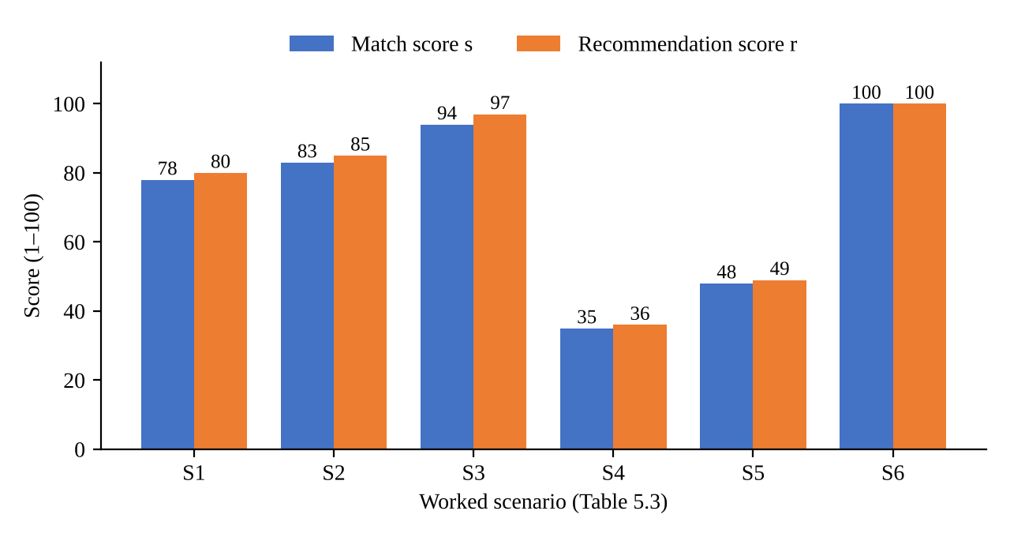
Figure 5.1: Match and recommendation scores for the scenarios of Table 5.3 (calculated, not measured)
Application Screenshots
The following screenshots were captured from the running application and are reproduced from the project presentation. They show a demonstration account ("Arjun") with sample users.
Figure 5.2: Login page with security code | Figure 5.3: User profile with Can teach and Wants to learn skills

Figure 5.4: Dashboard with token balance, reciprocal matches, recommendations and incoming requests
The dashboard (Figure 5.4) shows the token balance with a "Teach to earn" counter, the numbers of skills taught and wanted, reciprocal matches and active exchanges, the top reciprocal matches with a "Request swap" button, recommendations with an "AI Score" and reason sentences, the member's two skill lists with levels, and incoming exchange requests with their status (pending or accepted).
Figure 5.5: Live class with WebRTC video call and typed class chat | Figure 5.6: Mentors page – become a mentor or find one

Figure 5.7: Booking a mentor session (2-token fee) | Figure 5.8: My Bookings – mentor requests and booked sessions

Figures 5.9 and 5.10 provide illustrative mock-ups of the Matches page and token ledger to complete the report layout. Replace these mock-ups with direct screenshots from the running application when available.
Figure 5.9: Matches page (illustrative mock-up) | Figure 5.10: Tokens page with ledger (illustrative mock-up)

5.2 DISCUSSION
Three points follow from the implementation. First, the ranking is deterministic and explainable: any score can be reproduced from two skill lists and two profiles, and reciprocal matches rank above one-way matches by construction. Second, a match is only the beginning of an exchange; rooms, mentors and a reward for teaching give matched users a way to turn a suggestion into learning activity, an aspect left unspecified in the base work [5]. Third, a rule-based score is a reasonable starting point, but its quality depends on the skill names users enter. The percentages visible in the demonstration dashboard (for example 92% and 64% for reciprocal matches) are not values that Eq. 4.2 can produce, since a reciprocal match scores at least 78 and no reciprocal or one-way combination gives 92 or 64; it should be confirmed whether the screenshots used sample data or whether the scoring in the code differs from the conference paper as described in the project documentation. On privacy, the platform stores profile data, hashed passwords, chat messages and bookings; a deployment should obtain consent, restrict access, and review the assistant's optional external call before enabling it, because user questions would then leave the server. Video media travels peer to peer and is not stored by the application, and the token limits and learner confirmation should be monitored for abuse.

5.3 CHALLENGES AND LIMITATIONS
- Skills are compared as exact lower-cased strings, so "UI/UX Design" and "ui ux design", or "ML" and "machine learning", do not match; category and level are stored but not used in scoring.
- The score constants are not calibrated on data, and no experiment shows that higher scores lead to successful exchanges, although the interface calls the score an "AI Match Score".
- Matching runs two queries per candidate on every page that uses it, so its cost grows linearly with the number of users.
- The configuration is a development setup: debug mode on, all hosts allowed, secret key in the settings file and a process-local cache.
- Chat relies on polling, and the video call is a full mesh limited to six participants.
- The request status "Completed" is defined but no view sets it; the assistant's rule base is small.
- No automated tests exist for matching, requests, mentor booking, teaching rewards or the assistant, and the test suite has not yet been run for this report.

5.4 CONCLUSION
SkillLoop turns the idea of reciprocal skill exchange into a working Django application. Members declare what they can teach and want to learn; a transparent rule computes a reciprocal match score; and a recommendation layer ranks partners and explains each suggestion. Exchange requests, live rooms with text chat and browser-based video calls, mentor bookings and a teaching-based token mechanism let matched members begin learning together, while a captcha, honeypot and login throttling protect the entry points. By letting members teach what they know while learning what they need, the system supports peer-to-peer knowledge sharing in one environment. Its matching is simple and explainable rather than learned, which makes it easy to inspect and a sound baseline for future work. The effect of the platform on learning has not been measured and is a topic for later evaluation.

5.5 FUTURE WORK
The following are proposed enhancements; none is implemented in the current code.
- Project recommendation, as proposed in the base work [5].
- Normalization of skill names and use of category and level in the score; semantic matching with embeddings.
- Machine-learning-based recommendation and calibration of the score using user feedback.
- Matching among three or more users, a reputation signal based on confirmed lessons, and skill verification.
- Match notifications; a server database, shared cache, WebSocket updates and asynchronous matching; production settings and secret management.
- Mobile application support and a formal evaluation with real users, for example the share of suggestions that lead to accepted requests and completed sessions.

REFERENCES
[1] B. Sichtermana, “Supporting Peer Learning with Artificial Intelligence: A Systematic Literature Review,” Innovations in Education and Teaching International, pp. 1648–1664, published online Jul. 9, 2025, doi: 10.1080/14703297.2025.2530118.
[2] D. A. J., D. Naik, P. R., and V. P. Pattabiraman, “Dynamic Peer Learning Recommendations in E-Learning Using Hybrid Collaborative Filtering and Interaction-Based Clustering,” Frontiers in Education, vol. 10, art. 1660954, Jan. 29, 2026, doi: 10.3389/feduc.2025.1660954.
[3] O. A. S. Ibrahim, E. M. G. Younis, E. A. Mohamed, and W. N. Ismail et al., “Revisiting Recommender Systems: An Investigative Survey,” Neural Computing and Applications, vol. 37, pp. 2145–2173, 2025, doi: 10.1007/s00521-024-10828-5.
[4] J. Ma, J. Wang, X. Xie, Z. Zhou, H. Zhang, and Y. Wu, “CustMatcher: Enhancing Preference-Driven People-to-People Recommendation,” Visual Informatics, art. 100298, Mar. 2026, doi: 10.1016/j.visinf.2025.100298.
[5] S. Raj Kumar, R. Jai Shree Ram, and S. Rajagopal, “Skill Exchange Platform with Intelligent Skill Matching,” IRE Journal, vol. 9, no. 10, pp. 212–215, Apr. 2026, doi: 10.64388/IREV9I10-1715909.

